Paper Title
First Author
Department of Electronics and Communication Engineering
Organization Name, City, State, Country
Email- XYZ
Second Author
Department of Electronics and Communication Engineering
Organization Name, City, State, Country
Email- XYZ

Abstract- Abstract should be times new roman with 12 fount single spacing.The main focused of Watermarking is developing and introducing new techniques for watermark embedding and detection. Experimental results show that the embedded watermark is transparent and quite robust in face of various watermark images at high compression ratios and provides good results in terms of imperceptibility.

Keywords – Watermarking, Haar Wavelet, DWT, PSNR

I. Introduction
ICIAMR 2022 paper format font should be 12 in times new roman with single spacing.In recent years, the accessing of multimedia data or digital data has become very easy because of the fast development of the Internet. In other words, this development makes unauthorized distribution of multimedia data. For the protection of multimedia data, a solution known as watermarking is used. After the approximate 20 years’ research, different kinds of watermarking algorithm based on different theory concepts were introduced [1-3]. A digital watermark encodes the owner's license information and embeds it into data. Watermarking may be used to identify the image of owners’ license information and to track illegal copies.
The rest of the paper is organized as follows. Proposed embedding and extraction algorithms are explained in section II. Experimental results are presented in section III. Concluding remarks are given in section IV.

II. Proposed Algorithm

Watermark embedding algorithm –
In case of two-dimensional image, after a DWT transform, the image is divided into four corners, upper left corner of the original image, lower left corner of the vertical details, upper right corner of the horizontal details, lower right corner of the component of the original image detail (high frequency). You can then continue to the low frequency components of the same upper left corner of the 2nd, 3rd inferior wavelet transform.
- DWT Decomposition model
On the basis of such considerations, the algorithm uses a different color image multiplied by the weighting coefficients of different ways to solve the visual distortion, and by embedding the watermark, wavelet coefficients of many ways, enhance the robustness of the watermark.
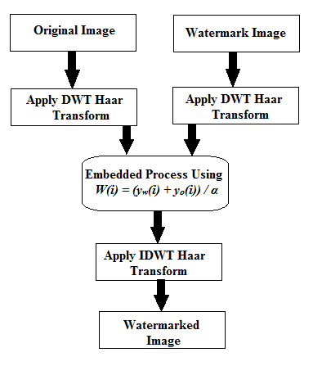
- Watermark embedding algorithm Block Diagram
After that we select the ordered coefficient from 1 to N to get N coefficient. the formulae of watermark embedding are as follows.
C_{w}(i) = Y_{o}(i)+α₁w(i) (1)
Where the parameter α is called embedding intensity and their effect of validity of the algorithm directly is apply after this process, after that apply the inverse wavelet transform to the image for find out watermark image.

2.2. Watermark Extraction algorithm –
The extraction algorithm process is the inverse of the embedding process. It is assumed that the watermark as well as the see value is available at the receiver end to the authorized users.
The operation of channel separation is applied on the watermarked color image to generate its sub images, and then 2-level discrete wavelet transform is applied on the sub images to generate the approximate coefficients and detail coefficients.

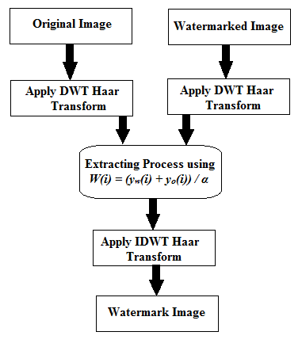
- Watermark Extraction algorithm Block Diagram
For this purpose the following formulae is use-
W(i) = (y_{w}(i) + y_{o}(i)) / α (2)
After this Execution the Inverse 2-level discrete wavelet transform is applied on the watermark data to generate three watermark images extracted.

III. Experiment and Result
The test set for this evaluation experiment watermark image randomly selected from the internet. Matlab 7.0 software platform is use to perform the experiment. The PC for experiment is equipped with an Intel P4 2.4GHz Personal laptop and 2GB memory.
The proposed scheme is tested using ordinarily image processing. From the simulation of the experiment results, we can draw to the conclusion that this method is robust to many kinds of watermark images.
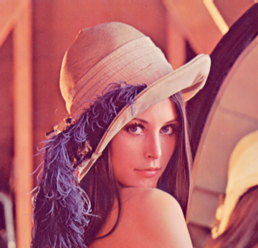
(a) (b)
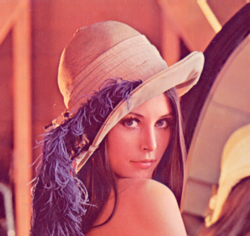
(c) (d)
Figure 4. (a) Original image (b) BJUT watermark Image (c) Watermarked image (d) Recovered watermark Image
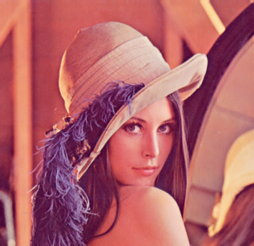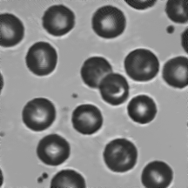
(a) (b)
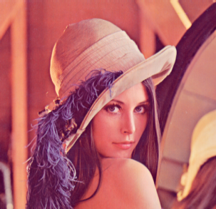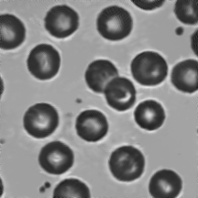
(c) (d)
Figure 5. (a) Original image (b) Bobbol watermark Image (c) Watermarked image (d) Recovered watermark Image


(a) (b)
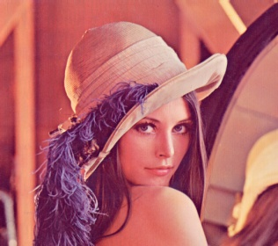
(c) (d)
Figure 4. (a) Original image (b) DDNT watermark Image (c) Watermarked image (d) Recovered watermark Image

Table -1 Experiment Result

 | Original Lena Image (PSNR) | Watermarked Lena Image (PSNR)
BJUT Watermark Image | 33.1224 | 41.9946
Bobbol Watermark Image | 33.1224 | 47.5911
DDNT Watermark Image | 33.1224 | 45.8103

Table 1 show the peak signal to noise ratio of performance of our proposed method of watermarked image and original image with various watermark image, where our watermarked images peak signal to noise ratio has a better performance than others.

IV.CONCLUSION

REFERENCES

- B. Corona, M. Nakano, H. Pérez, “Adaptive Watermarking Algorithm for Binary Image Watermarks”, Lecture Notes in Computer Science, Springer, pp. 207-215, 2004.
- A. A. Reddy and B. N. Chatterji, "A new wavelet based logo-watermarking scheme," Pattern Recognition Letters, vol. 26, pp. 1019-1027, 2005.
- P. S. Huang, C. S. Chiang, C. P. Chang, and T. M. Tu, "Robust spatial watermarking technique for colour images via direct saturation adjustment," Vision, Image and Signal Processing, IEE Proceedings -, vol. 152, pp. 561-574, 2005.
- F. Gonzalez and J. Hernandez, " A tutorial on Digital Watermarking ", In IEEE annual Carnahan conference on security technology, Spain, 1999.
- D. Kunder, "Multi-resolution Digital Watermarking Algorithms and Implications for Multimedia Signals", Ph.D. thesis, university of Toronto, Canada, 2001.
- J. Eggers, J. Su and B. Girod," Robustness of a Blind Image Watermarking Scheme", Proc. IEEE Int. Conf. on Image Proc., Vancouver, 2000.
- Barni M., Bartolini F., Piva A., Multichannel watermarking of color images, IEEE Transaction on Circuits and Systems of Video Technology 12(3) (2002) 142-156.
- Kundur D., Hatzinakos D., Towards robust logo watermarking using multiresolution image fusion, IEEE Transcations on Multimedia 6 (2004) 185-197.
- C.S. Lu, H.Y.M Liao, “Multipurpose watermarking for image authentication and protection,” IEEE Transaction on Image Processing, vol. 10, pp. 1579-1592, Oct. 2001.
- L. Ghouti, A. Bouridane, M.K. Ibrahim, and S. Boussakta, “Digital image watermarking using balanced multiwavelets”, IEEE Trans. Signal Process., 2006, Vol. 54, No. 4, pp. 1519-1536.

